CAMME 2019 Registration Form
2019 3rd International Conference on Aerospace, Mechanical and Mechatronic Engineering
Feb.21-24 | Kuala Lumpur, Malaysia | www.camme.org
NOTE: Please send the required documents: 1. Filled Registration Form, 2. Payment Voucher to camme@iased.org to finish the registration. (Mail Subject: Listener+Registration).
- ATTENDEE INFORMATION
*Full Name:
*Position√: Prof. □  Assoc. Prof. □  Asst. Prof. □ Dr. □  Mr. □  Ms. □
*Affiliation & Country:
*Email: *Mobile:
Emergency Contact(Name&Mobile):
Address& Zip Code (for post use):
Catering Service(Feb.23)√: Lunch □ Dinner □
Special dietary√: Diabetic □ Vegetarian □ Muslim □ Other □ (please specify: )
Special requirements:
* Receipt Issued to:
Research Area:

1-inch-Photo here

- REGISTRATION FEE(by US dollar)
Items | Early  (Until Dec. 21) | Regular  (Until Feb. 15) | On-site  (After Feb. 15) | Your Choice
Listener | USD 300 | USD 320 | USD 350
Extra Banquet Ticket | USD 50
One Day Tour | TBD
Total Registration Fees

- PAYMENT INFORMATION
Online Payment linkage
http://meeting.yizhifubj.com.cn/web/main.action?meetingId=351
* VISA /Master can valid. No handling fees, please calculate the amount and pay.
Please fill your E-mail address used for payment and Confirmation Number you received after paying.
E-mail: | Confirmation Number:

- IASED MEMBER APPLICATION
Join IASED now to quality for member registration rates. Please compile and return the Membership Form along with your CV to membership@iased.org. Your application will be processed in 5 working days.
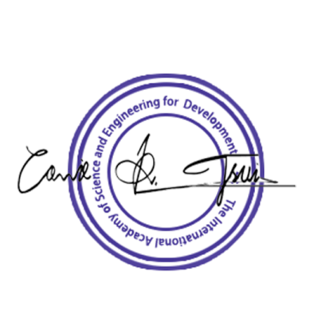

CAMME 2019 Conference Committee
Kuala Lumpur, Malaysia

